**EXP NO 9** Create a simple cloud software application for Hospital information system for SIMATS Hospital using any Cloud Service Provider to demonstrate SaaS with fields of patient name, age, address, phone, email, Attender name, attender phone, doctor name, diseases, etc.

**PROCEDURE**

**STEP 1** GO TO ZOHO.COM

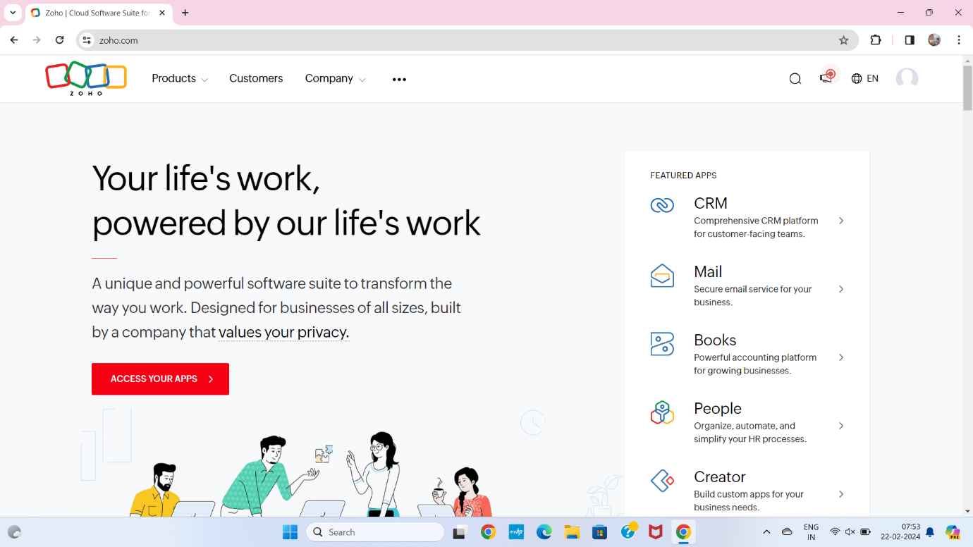

**STEP2** LOGIN TO THE ZOHO.COM

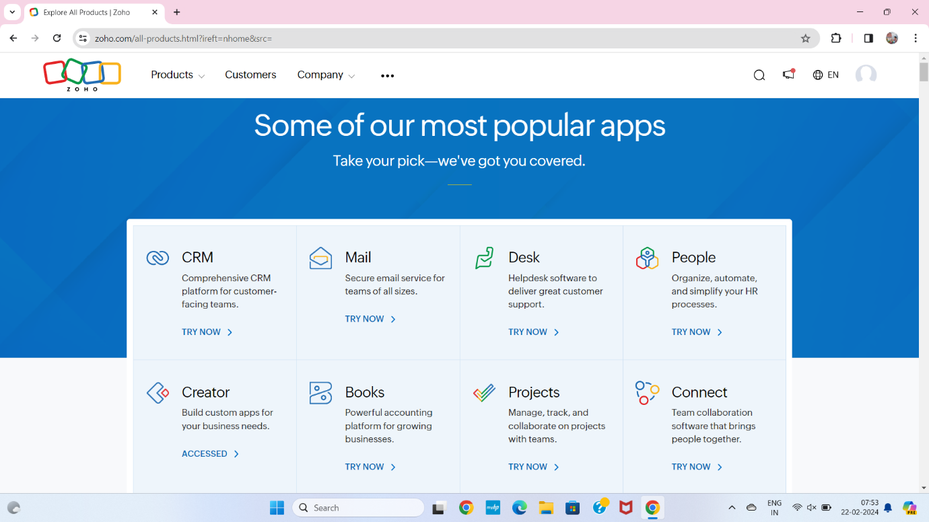

**STEP 3** SELECT A CREATE FROM SCRATCH

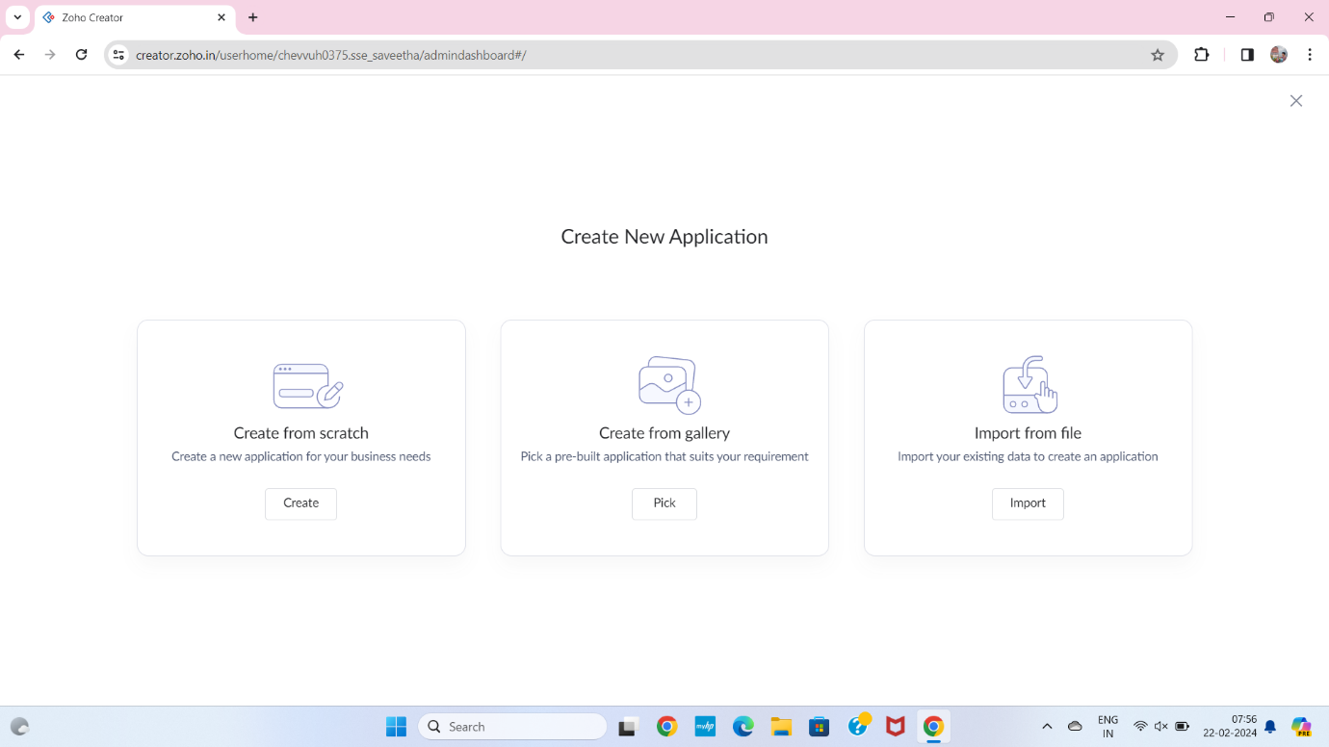

**STEP 4** SELECT APPLICATION NAME AS HOSPITAL INFORMATION SYSTEM

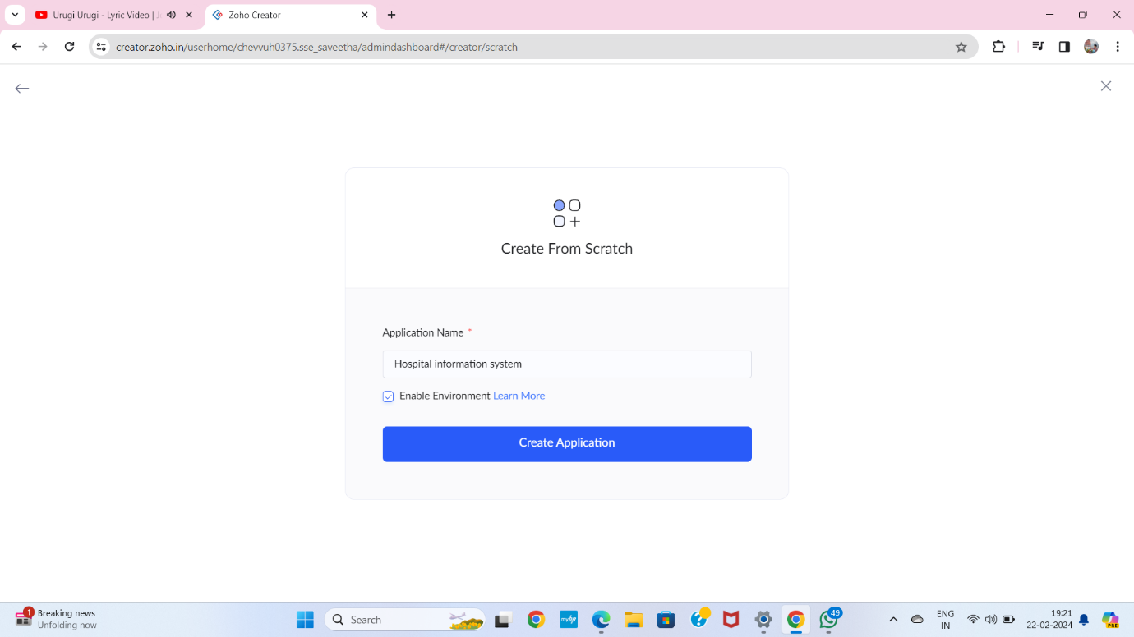

**STEP 5** CREATE A NEW FORM

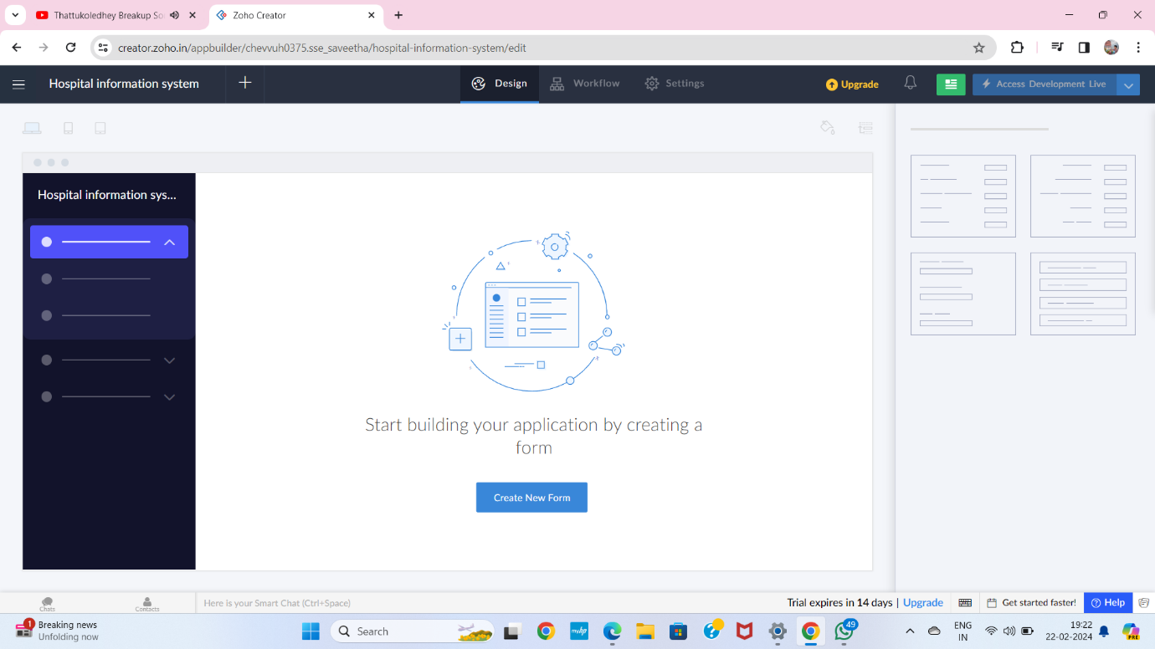

**STEP 6** SELECT BASIC FIELD FROM GIVEN BELOW AND DEVELOP APPLICATION

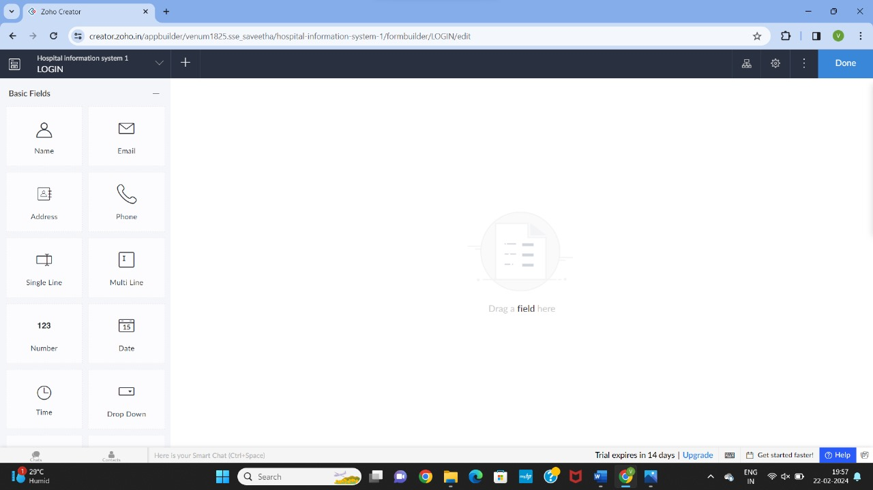

**STEP 7** THE SOFTWARE HASE BEEN CREATED SLOT BOOKING HEALTH CHECK UP

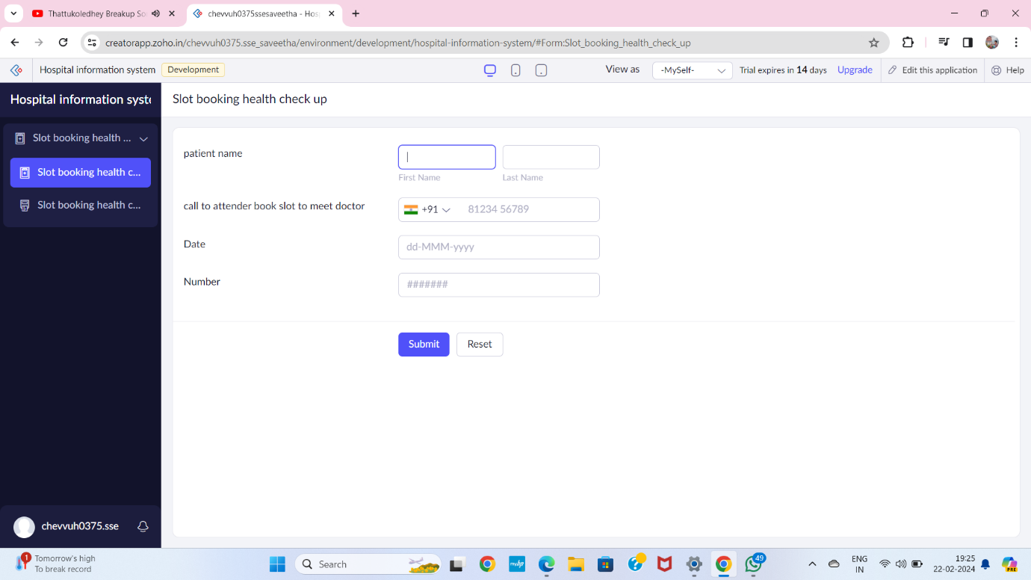

**STEP 8** THE SOFTWARE HASE BEEN ATTENDER OR RECEPIONIST

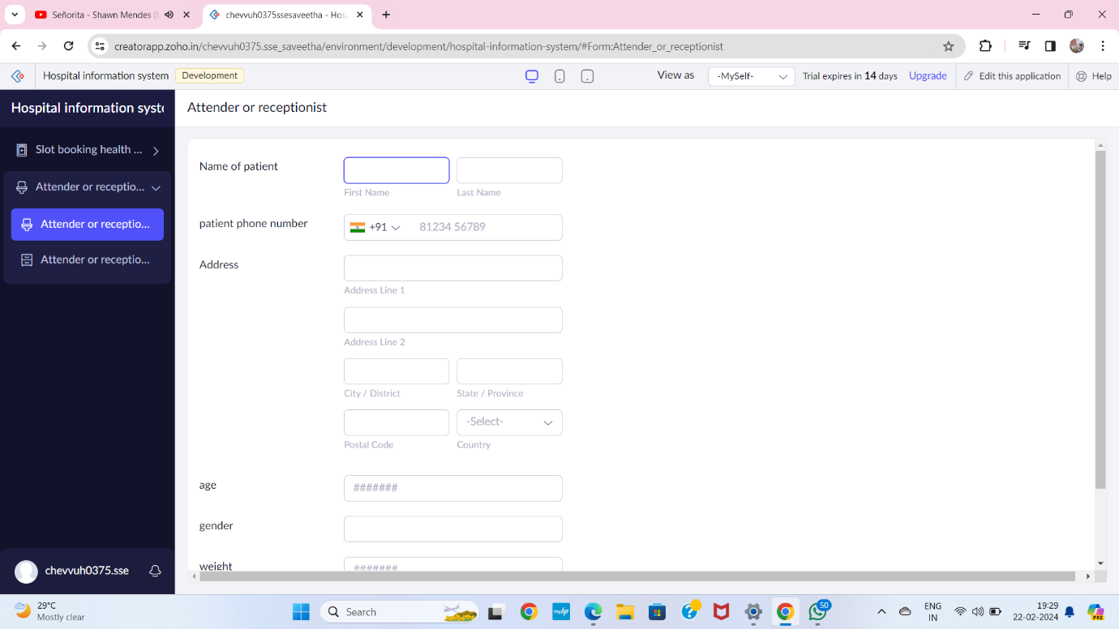

**STEP 9** THE SOFTWARE HASE BEEN CREATED OP FEES

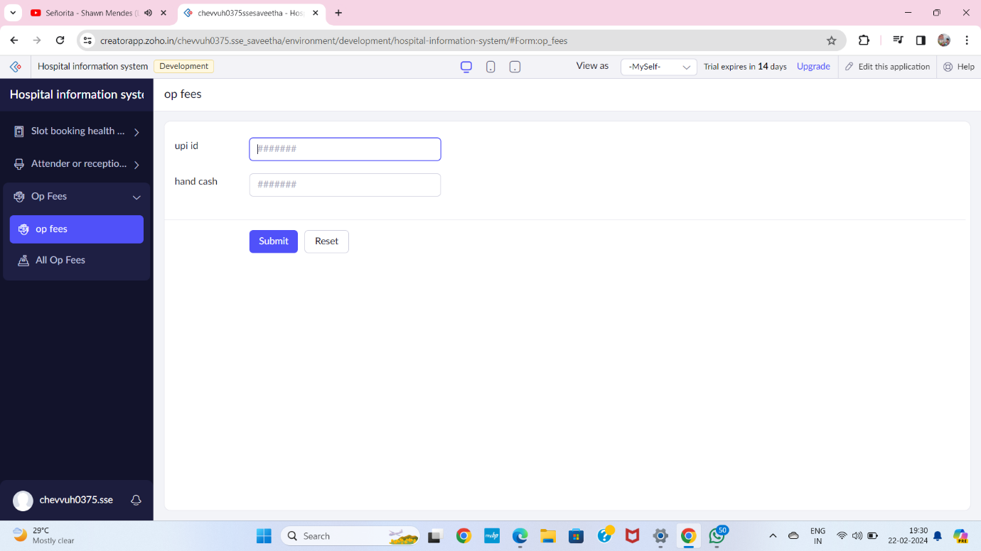

**STEP 10** THE SOFTWARE HASE BEEN CREATED DOCTOR

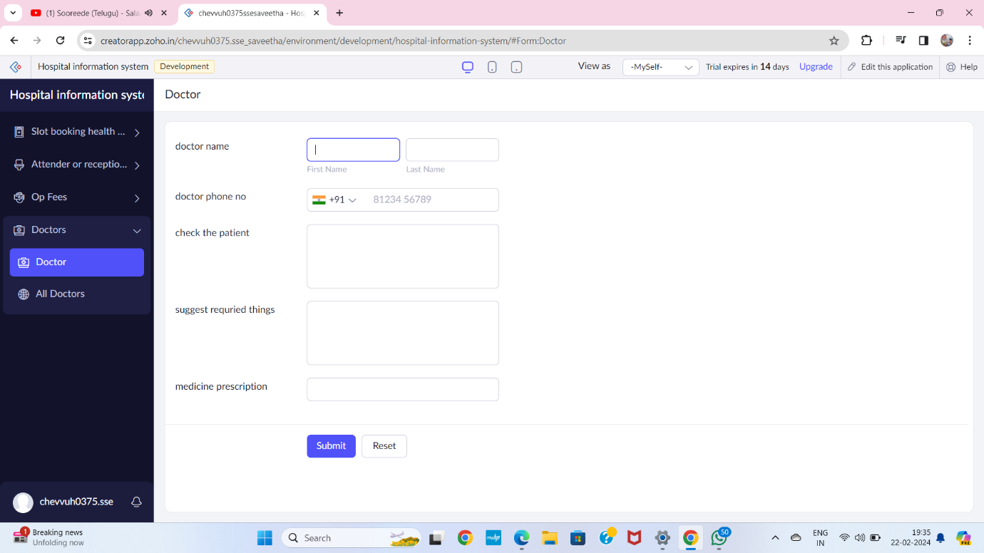

**STEP 11** THE SOFTWARE HASE BEEN CREATED MEDICAL SHOP

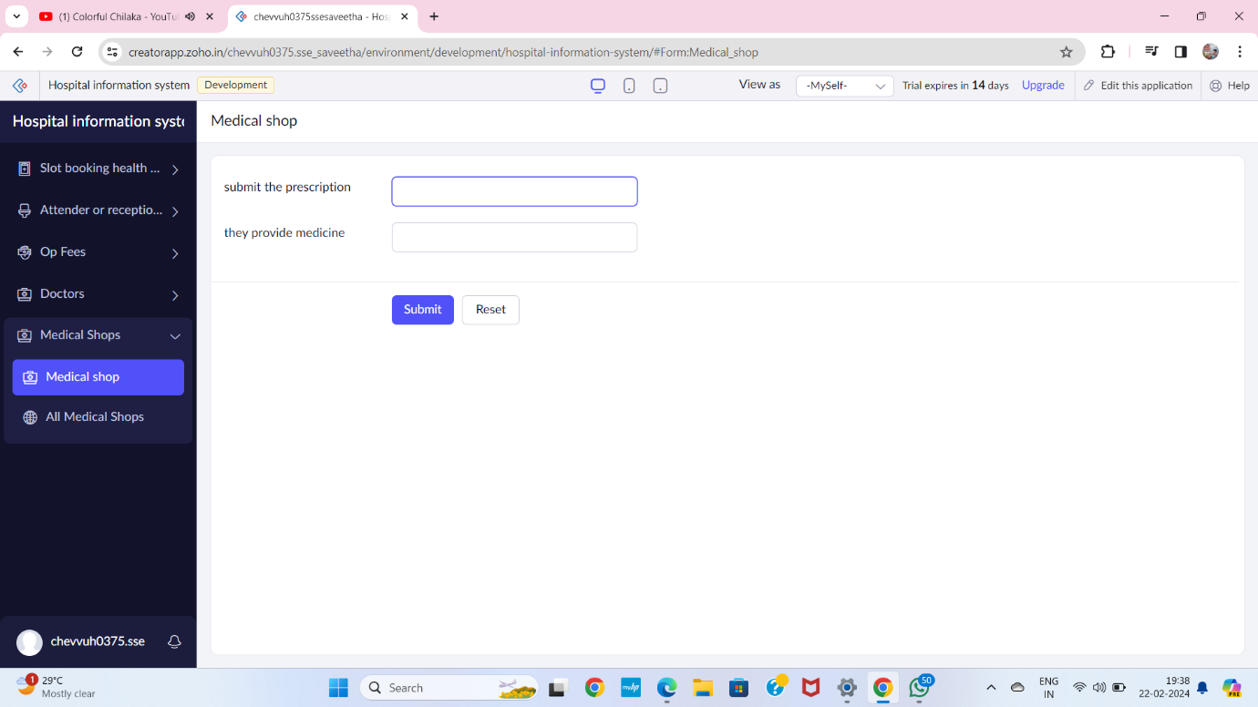

**STEP 12** THE SOFTWARE HASE BEEN CREATED PAY BILL IN MEDICAL SHOP

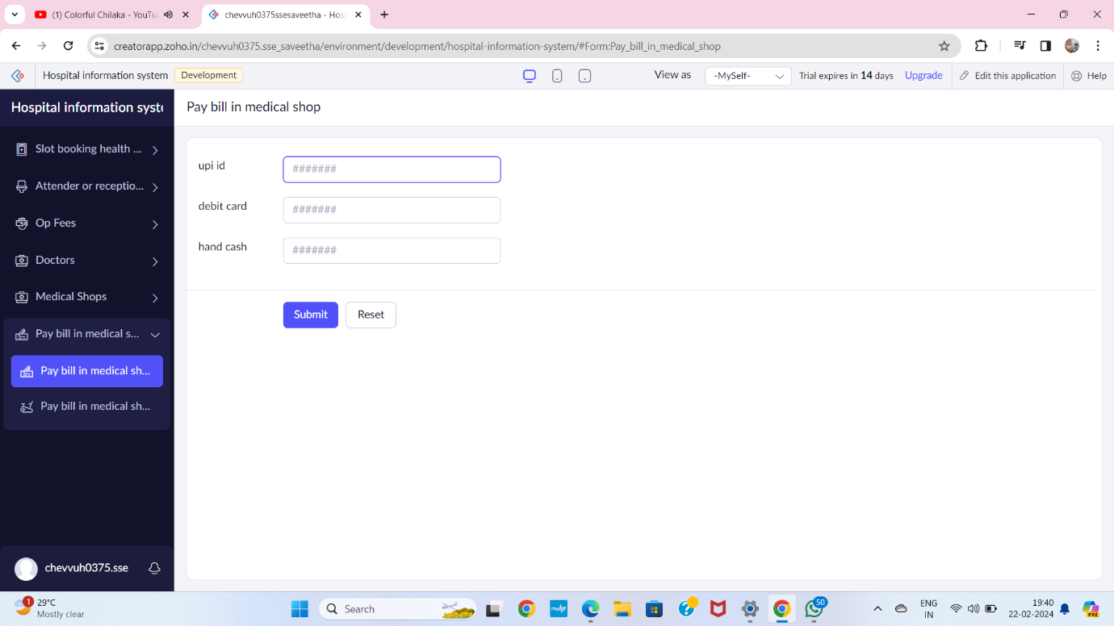

**STEP 13** THE SOFTWARE HASE BEEN CREATED

